Solent University

**Faculty of Business, Law and Digital Technologies**

### Computing Foundation Year

**2020**

**Filipe Bastos**

**“Teamwork struggles ”**

Tutor: Name

Date of submission :11/13/2020

Table of Contents

Computing Foundation Year I

1. Introduction 3

3. Section 4

.Creativity 5

.Ability to listen to others' ideas 6

.Respect 6

.Be persuasive 6

.Be a self-conscious person 6

.Be a reliable member 6

4. Section 7

5. Section 8

6. Conclusions 9

8. Reference list 10

9. Bibliography 11

**List of Figures**  
**Figure 1:**

**Importance of teamwork leader chip by Muhammad UMAIR**

[**https://www.google.com/url?sa=i&url=https%3A%2F%2Fmedium.com%2F%40imumair.mech%2Fimportance-of-teamwork-in-leadership-42570c9560c9&psig=AOvVaw1WpW6dQyYhIrnaiJKM33lO&ust=1605310438125000&source=images&cd=vfe&ved=0CAIQjRxqFwoTCMjh6s-V_uwCFQAAAAAdAAAAABAE**](https://www.google.com/url?sa=i&url=https%3A%2F%2Fmedium.com%2F%40imumair.mech%2Fimportance-of-teamwork-in-leadership-42570c9560c9&psig=AOvVaw1WpW6dQyYhIrnaiJKM33lO&ust=1605310438125000&source=images&cd=vfe&ved=0CAIQjRxqFwoTCMjh6s-V_uwCFQAAAAAdAAAAABAE)

**Figure 2:** Teamwork has become increasingly difficult in the 2000s

[**https://www.google.com/url?sa=i&url=http%3A%2F%2Ftilastokeskus.fi%2Fajk%2Ftiedotteet%2F2009%2Ftiedote_009_2009-08-13_en.html&psig=AOvVaw2UatYRXEg4ZdNBeOp7NLyq&ust=1605361235686000&source=images&cd=vfe&ved=0CA0QjhxqFwoTCJCPyePS_-wCFQAAAAAdAAAAABAb**](https://www.google.com/url?sa=i&url=http%3A%2F%2Ftilastokeskus.fi%2Fajk%2Ftiedotteet%2F2009%2Ftiedote_009_2009-08-13_en.html&psig=AOvVaw2UatYRXEg4ZdNBeOp7NLyq&ust=1605361235686000&source=images&cd=vfe&ved=0CA0QjhxqFwoTCJCPyePS_-wCFQAAAAAdAAAAABAb)

# 1. Introduction

in this work, I will talk about group work, why sometimes it doesn't work, methods that can be followed to improve communication and group performance. Part of the information used in this work will be based on the classes, the rest will be based on my research on this topic.

# 2. Section

If you stop and think, creating groups is something truly healthy for good relationships between people, whether in the workplace, at school, at the gym, or anywhere else. This process helps to make day-to-day activities lighter, the routine becomes something more pleasurable, in addition to helping to maintain a pleasant and safe environment, whatever it may be.

However teamwork can often be difficult and complicated, due to disagreements and unsatisfaction with teammates.

That is why it is not in team work who has more experience or qualifications for a given area. What really matters is how each person can work and articulate the project's problems with each other.

The main skills needed to achieve a good environment between the team and good productivity are:

.creativity

.ability to listen to others' ideas

. be a reliable member

.respect

.be persuasive

.be a self-conscious person

The first thing to do would be to delegate a leader or person responsible for the group work. That person would need to know the other members of the team well, as it will be they who will delegate the functions of each one. Team work will be much more productive if each one is dedicated to an area where you feel more comfortable. So the person responsible for the group work has a fundamental role. This will have to be a person with more skills when it comes to group work.

The most difficult part of group work is delegating a good leader because without a leader the group is in danger of leaving the teams spinning their wheels working on things without a direction to follow. That person would need to know the other members of the team well because it will be she who will delegate the functions of each one. Team work will be much more productive if each one is dedicated to an area in which they feel more comfortable. So the person responsible for the group work has a fundamental role. the person with the most skills when it comes to group work.

.

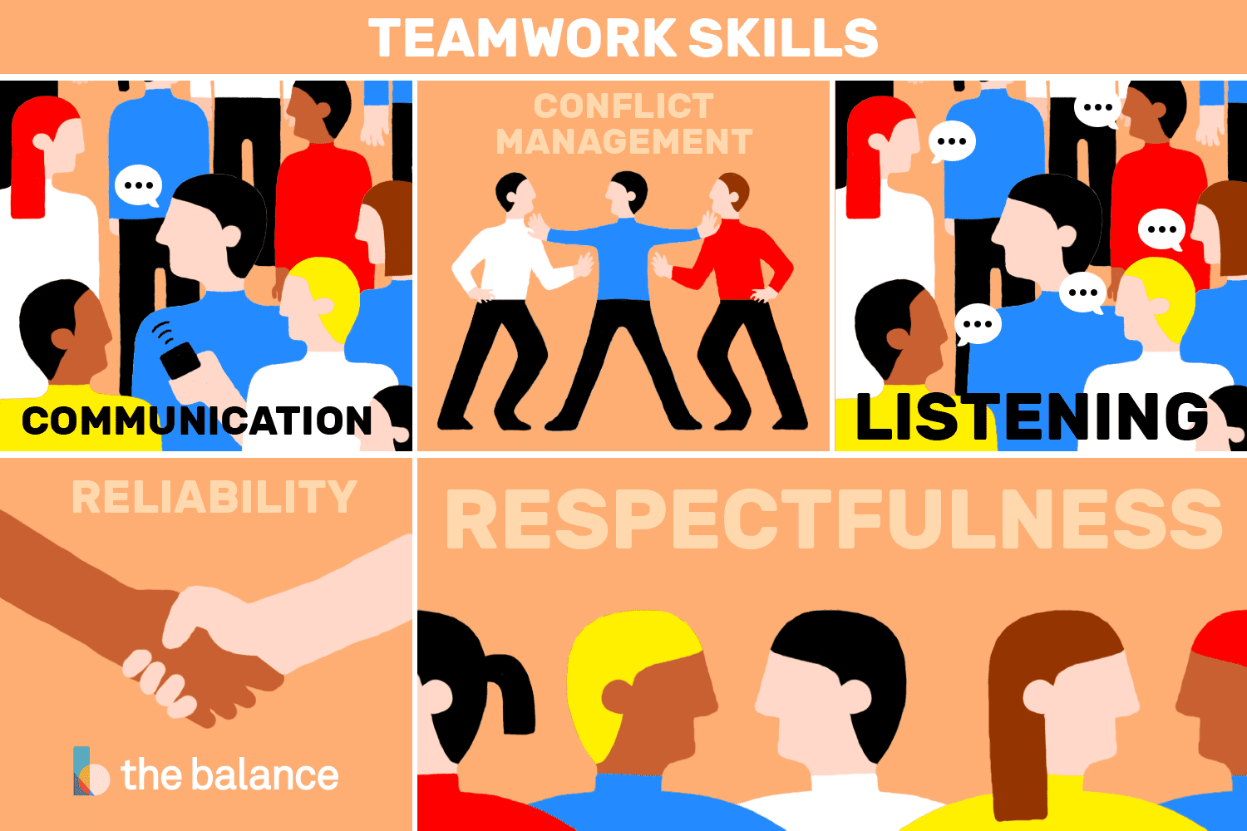

Figure 1:teamwork basic skills

3. Section

there are ways to make teamwork work, but there are certain skills

these skills are essential and without them group work can never work.

These skills are going to make you improve the teamwork results:

## **.Creativity**

Many companies boast about being innovative and creative, and most are in some way, shape or form. But if this were actually true, companies would be gaining far more of the benefits of a creative workplace. [Best Practice Consulting](https://www.bestpracticeconsulting.com.au/_blog/Articles/post/Fostering_creativity_in_the_workplace/), an organizational consulting firm, explains three key benefits.

**Better Teamwork and Team Bonding**

Creativity inspires employees to work with each other. As they have new ideas, they seek out colleagues for their feedback. By design, the creative process encourages collaboration, and this is the most important benefit of offering a workplace where creative thinking can occur.

Team bonding also helps the overall engagement among employees. Interactions are more likely among co-workers, even those who do not work together regularly. An increased level of comfort in a team is a positive for any organization.

**Improved Ability to Attract and Retain Employees**

By developing an environment where creative minds are welcome, companies can attract more talented professionals. They are able to fill positions more effectively and efficiently. A similar effect occurs with current employees, who are more likely to stay on board because of the creative environment. They become content with their job and commit to remaining with the company long term.

**Increased Problem-solving**

Certainly, the most important aspect of creativity is how it affects the work. With the ability to think creatively and outside the box, employees are more likely to come up with unique and innovative solutions to obstacles they encounter. This eagerness to solve problems can lead to new ways to accomplish tasks and run the organization more effectivel

## **.Ability to listen to others' ideas**

the ability to listen to others' ideas and a crucial part of team work, and more often referred to as active listening. the ability to listen and accept opinions different from ours can often be complicated and overwhelming. Knowing how to listen involves much more than just listening in silence to what others are saying - that is being an educated listener. Research shows that those who are considered the best listeners have small stimulating interactions, in order to provoke insights and new points of view in the interlocutor. This shows that the listener is not only listening, but paying attention and processing all the information, in order to work on the data that can contribute to the conversation.

## **.Respect**

respect and the first step to take when it comes to group work if the members of the team do not respect each other it will never be possible to accomplish the other points necessary for a good team work

## **.Be persuasive**

The art of convincing is persuasion. With it, a person can influence others using logical and rational resources, making the interlocutor agree or even change his mind in a given situation

## **.Be a self-conscious person**

“Having emotional self-awareness means being aware of your own emotions, and experiencing the alignment between them and thoughts, so that, in a coherent way, the individual builds the reality that he wants to live”( [eliana Ferrarez](https://cispintercambio.com/2019/07/29/o-poder-da-autoconsciencia-e-o-papel-do-lider/elianaferrarez.com.br),)

## **.Be a reliable member**

if it does not seem difficult to assimilate the idea that trust is essential for teamwork, the same cannot be said of putting this idea into practice. To trust is to place yourself in a situation of vulnerability before the one you trust, to believe in your good intentions and that he will do what is right. For the sake of emotional economy and self-preservation, people do not openly trust everyone who crosses their path; far from it, they have very personal and subjective criteria, developed throughout life, that lead them to decide whether to trust or not. Add to that the fact that the business environment is competitive, reflecting the reality of the labor market and the world in which we live, and we realize the complexity of the theme.

For all the reasons, the idea of ​​building trust between team members raises the inevitable question: how to make people trust each other more?

simple just comply with all the criteria that I mentioned above. I said it was simple I never said it would be easy.

# 4. Section

This is corroborated by the science that the team work streamlines and increases the results and the satisfaction of the workers. So each one can be focused on what they like best and which is best and with the bonuns of being able to communicate during the work. I think this of course for everyone who likes to spend eight hours working without being able to talk to anyone.

Soon the tables that I will show next are no surprise.

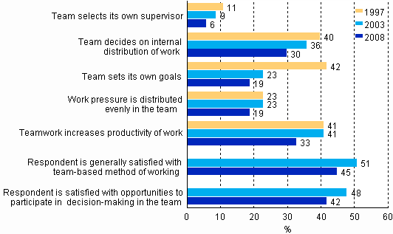

Image 2 :teamwork evolution

# 

# 5. Conclusions

In short, group work is something that is used today in any job. Because we live in society and without it, it is practically impossible to have the results that are expected of us. Often it is difficult to get the teamwork to work, due to conflicts and disagreements.

But when it comes to working in a group, we have to put all our directives aside and focus on what matters: work

# 

# 6. Bibliography

* http://www.jjabrasil.com.br/a-importancia-de-saber-ouvir-em-seu-ambiente-de-trabalho-2/
* https://administradores.com.br/artigos/confianca-e-trabalho-em-equipe
* https://www.ibccoaching.com.br/portal/importancia-em-se-respeitar-o-proximo-no-trabalho/
* https://medium.com/@imumair.mech/importance-of-teamwork-in-leadership-42570c9560c9
* https://blog.pitagoras.com.br/poder-de-persuasao/
* https://www.conovercompany.com/teamwork-active-listening/
* https://www.thebalancecareers.com/list-of-teamwork-skills-2063773
* https://stand.delaware.gov/documents/teamwork-dreamwork.pdf
* https://www.emerald.com/insight/content/doi/10.1108/hrmid.2011.04419cae.002/full/html?journalCode=hrmid